**Chapter 2: Socio-technical systems**

**EXERCISES [4]**

4. Consider a security system which is intended to protect against intrusion and to detect fire. It incorporates smoke sensors, movement sensors, door sensors, video cameras under computer control, located at various places in the building, an operator console where the system status is reported, and external communication facilities to call the appropriate services such as the police and fire departments. **Draw a block diagram of a possible design for such a system**.

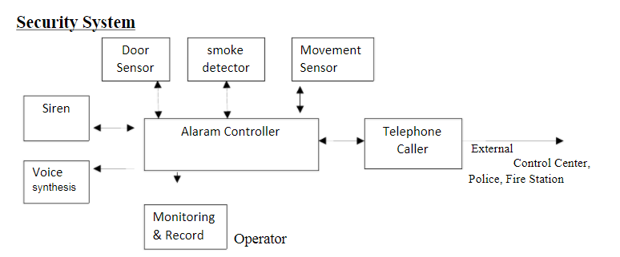

Security System

Door sensor - To monitor who enter the building and room

Movement Sensor - To monitor and alert if unauthorize person is enter.

Smoke detector - To detect smoke, typically as an indicator of fire.

Monitoring and Record sub system - To monitor building and report to

operator. To record all CCTV camera.

Water Level

Sensor

Water System

Controller

Water

Pump

Water Pump

Controller

Alaram Controller Telephone

Caller

Siren

Voice

synthesis

er

Door

Sensor

Movement

Sensor

smoke

detector

Monitoring

& Record

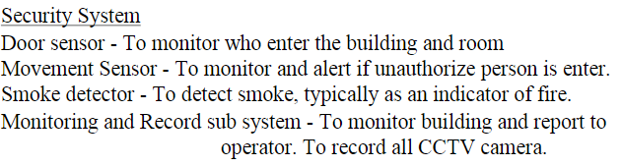

Telephone caller - To submit external control center, township police

statation, Township fire station.

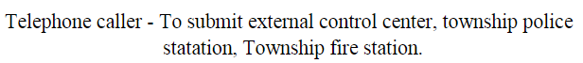

5. A flood warning system is to be procured which will give early warning of possible flood dangers to sites that are threatened by floods. The system will include a set of sensors to monitor the rate of change of river levels, links to a meteorological system giving weather forecasts, links to the communication systems of emergency services (police, coastguard, etc.), video monitors installed at selected locations, and a control room equipped with operator consoles and video monitors.   
Controllers can access database information and switch video displays. The system database includes information about the sensors, the location of sites at risk and the threat conditions for these sites (e.g., high tide, southwesterly winds), tide tables for coastal sites, the inventory and location of flood control equipment, contact details for emergency services, local radio stations, and so on.

**Draw a block diagram of a possible architecture for such a system**. You should identify the principal sub-systems and the links between them.

